**16-BIT MULTIPLICATION**

**EXP NO:7**

**AIM:** To write an assembly language program to implement 16-bit multiplication using 8086 processor.

**ALGORITHM:**

1. First load the data into AX (accumulator) from memory 2050.
2. Load the data into BX register from memory 2052.
3. Multiply BX with accumulation AX.
4. Move data from AX (accumulator) to memory.
5. Move data from DX to AX.
6. Move data from AX (accumulator) to memory.
7. Halt.

**PROGRAM:**

LHLD 2050

SPHL

LHLD 2052

XCHG

LXI H,0000H

LXI B,0000H

AGAIN; DAD SP

JNC START

INX B

START; DCX D

MOV A, E

ORA D

JNZ AGAIN

SHLD 2054

MOV L, C

MOV H,B

SHLD 2056

HLT

**INPUT:**

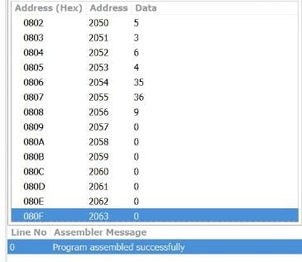

**OUTPUT:**

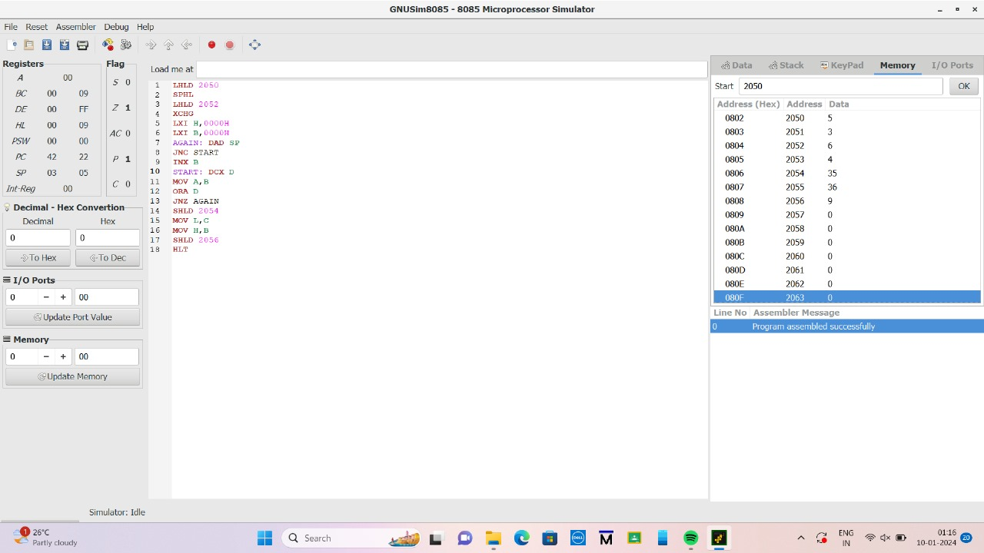

**RESULT:** Thus the program was executed successfully using 8086 processor simulator.